**21.1. What is CSS?**

**21.1.1. Background**

As discussed in the previous chapter, HTML lays out the structure of a document. With HTML attributes, programmers can add some specification to tags. Yet, when programmers make pages with only HTML, the web pages look rather bland. When making a web site, the structure of the page elements is important, as is how those elements appear.

While HTML creates the structure and content of the page, CSS adds the styling to make it beautiful! Cascading Styling Sheets (**CSS**) is a style sheet language that allows programmers to add styling to web documents. With CSS, programmers can change background and font colors, the size of different elements, and many more things.

CSS works by applying style rules to different elements. A style rule could be: “Make this lettering purple” or “Make this font Helvetica”. CSS is a *cascading* style sheet language because the style rules apply based on a specific precedence, so the rules “cascade”.

**Note**

This book covers style rules and the order of precedence in greater detail in the third section of this chapter.

**21.1.2. Check Your Understanding**

**Question**

What kind of language is CSS? Check ALL that apply.

1. Markup Language
2. Programming Language
3. Style Sheet Language
4. Coding Language

# 21.2. CSS Structure

## 21.2.1. Writing CSS

Programmers can change a lot of different styling using CSS **rules**. A rule includes the selector and a declaration block. A **selector** determines which elements will be affected by the rule. Inside the declaration block, programmers set CSS properties to specific values. CSS has a lot of different properties and it would be impossible to memorize them all.

selector {

declaration block

}

### 21.2.1.1. CSS Selectors

CSS has three different selectors that the programmer can use to make their style choices.

The first one that most beginners start with is the **element selector**. Element refers to the HTML elements, so if the selector used is **p**, then the styling will apply to all paragraph elements.

The **id selector** is a specific id given to one element for CSS styling, for example when one paragraph on the web page needs to be bright pink.

The final selector is the **class selector**. A class is a group of HTML elements that need the same styling. The class name is determined by the programmer. The class name should be unique and have meaning like variable names.

### 21.2.1.2. Declaration Blocks

The declaration block is a series of initializations of style rules in CSS for a selector. Programmers can write CSS two different ways depending on where the CSS is in relation to the HTML document. We will go more in depth about the differences between CSS locations in the next section.

Here is an example of how to write the declaration block for internal and external CSS:

|  |  |
| --- | --- |
| 1  2  3  4  5 | **selector** {  property: value;  property: value;  property: value;  } |

For inline CSS, the declaration block is inside one line of HTML like so:

<**tag** **style**="property:value;property:value;property:value;">content</**tag**>

Every property in CSS has a default value. For example, **font-color** defaults to “black”. For that reason, programmers only need to declare the CSS properties they want to change from the default.

**Note**

HTML elements also have a default appearance. When creating web pages, we should be aware of which elements are inline elements and which elements are block elements. Inline elements will not start a new line (such as **<b>**, **<em>**, and **<span>**) and block display elements do (such as **<h1>**, **<div>**, and **<p>**).

### 21.2.1.3. CSS Examples

Here are three different examples of how we can use selectors to make the text in a paragraph pink.

**Element Selector**

Using the element selector to change the color of all **<p>** elements,

|  |  |
| --- | --- |
| 1  2  3 | **p** {  font-color: **pink**;  } |

Using the element selector will make all paragraph elements on the page have pink text.

**Class Selector**

Now, if a few of the paragraphs on the page are given the class **pink-paragraph** on the HTML document, like so: **<p class="pink-paragraph">content</p>**. To use the class selector in CSS, we would write something like:

|  |  |
| --- | --- |
| 1  2  3 | .pink-paragraph {  font-color: **pink**;  } |

In CSS, the class selector is preceded by **.**.

**Id Selector**

If one paragraph is going to have pink text, the id selector on the HTML document would look like: **<p id="pinkParagraph">content</p>**. In CSS, we would use the id selector to make the paragraph pink:

|  |  |
| --- | --- |
| 1  2  3 | #pinkParagraph {  font-color: **pink**;  } |

In CSS, the id selector is preceded by **#**.

## 21.2.2. Linking CSS to HTML

To get started with CSS, programmers need to add CSS to HTML.

There are three different places to add CSS in an HTML file as indicated above:

1. External: The CSS is in a separate file linked to the HTML document in the **<head>**. External linking of CSS is great for when programmers have large quantities of CSS that apply to the whole page.

|  |  |
| --- | --- |
| 1  2  3  4 | <**head**>  <**title**>My Web Page</**title**>  <**link** **rel**="stylesheet" **type**="text/css" **href**="styles.css">  </**head**> |

1. **link** is an HTML tag that tells the browser to connect what is inside the linked file to the web page content. **rel**, **type**, **href** are all HTML attributes that are required to properly link CSS and let the browser know that CSS is what is in the file and where the file is. **rel** should be set to “stylesheet”, because it designates how the link relates to the page. **type** will be set to “text/css” for all stylesheets. **href** is where the programmer enters the path to the stylesheet that should be used for the page.
2. Document or internal: All CSS styling is inside the HTML file, but within the **<head>**. Internal use of CSS is great for when the programmer has a small amount of CSS that applies to the whole document.
3. <head>
4. <title>My Web Page</title>
5. <style>
6. selector {
7. declaration block
8. }
9. </style>
10. </head>
11. Inline: Programmers add CSS styling to individual tags. This is a good place to add some specific styling. There is no selector in inline CSS; instead, the **style** attribute is used. This is because the styling only applies to that one instance of the HTML tag.
12. <**tag** **style**="declaration block">content</**tag**>

### 21.2.2.1. Order of Precedence

Because there is an order of precedence to the location of CSS, it is important to be able to add or change CSS in all three locations. Programmers use this to their advantage if they want to be very specific with overwriting some CSS for one element. Inline CSS is highest in precedence with internal CSS being next and then external CSS is lowest.

## 21.2.3. Check Your Understanding

**Question**

What is the order of precedence in CSS?

1. Internal > External > Inline
2. Inline > Internal > External
3. Inline > External > Internal
4. External > Internal > Inline

# 21.3. CSS Rules

Below are some examples of common CSS properties and what they do. It is by no means an exhaustive list of CSS properties, but it is a good place to start.

## 21.3.1. Good CSS Properties to Know

| **CSS Property** | **Definition** | **Default Value** |
| --- | --- | --- |
| **font-size** | Changes the size of the font. | medium or 20px |
| **color** | Changes the text color. | black |
| **font-family** | Changes the font types. | Depends on the browser |
| **background-color** | Sets the color of the background of an element. | transparent |
| **text-align** | Aligns the text within an element. | left |

## 21.3.2. CSS Example

Adding CSS to the HTML page about Space Plants is the logical next step in building a website about this cool discovery. The astronauts building the site used the **body**, **h1**, and **p** selectors to change some of the styling of those elements.

|  |  |
| --- | --- |
| 1  2  3  4  5  6  7  8  9  10  11  12  13  14  15  16  17  18  19  20  21  22  23 | ***<!DOCTYPE html>***  <**html**>  <**head**>  <**title**>Plant-Loving Astronauts</**title**>  <**style**>  **body** {  **background-color**: **cornflowerblue**;  }  **h1** {  **color**: **green**;  }  **p** {  **font-size**: **18px**;  }  </**style**>  </**head**>  <**body**>  <**h1**>Space Plants Are Cool</**h1**>  <**p**>NASA discovers that plants can live in <**b**>outer space</**b**>. More innovations from this discovery to follow.</**p**>  <**img** **src** = "space-flower.jpg" **alt** = "Flower floating in space.">  *<!-- This image was taken by NASA and is in the Public Domain -->*  </**body**>  </**html**> |

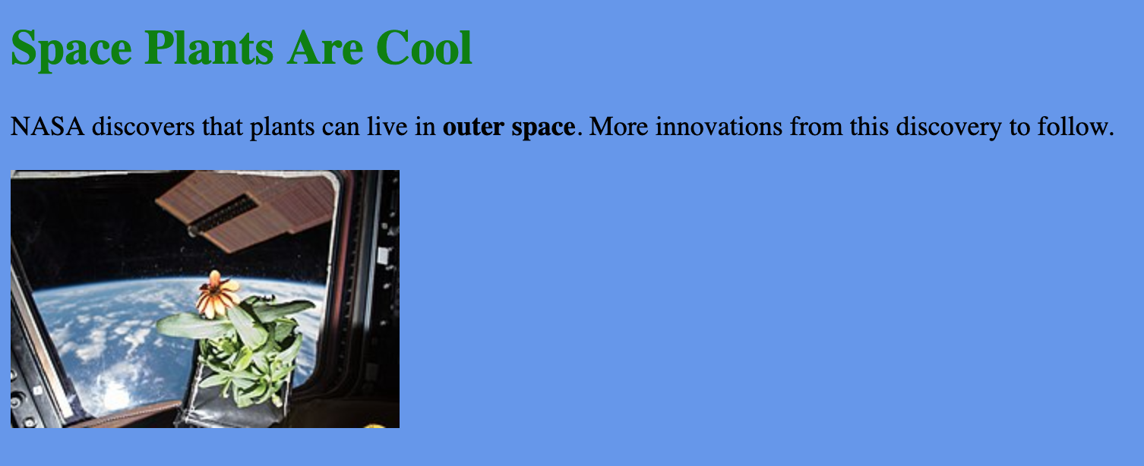

## 21.3.3. Check Your Understanding

**Question**

Find a CSS property and give its name, definition, and default value. Please do NOT use one of the ones above.

**21.4. Exercises: CSS**

We have built a website for you to test your CSS knowledge. Check out the [repl.it](https://repl.it/@launchcode/CSSExercises/)!

For the exercises, add the following style rules to the website:

1. Change the background color to yellow.
2. Change all paragraph text color to green.
3. Change all **h1** to 36 px font size.
4. Align all text to the center of the page.
5. Let’s say that you don’t like aligning all of the text to the center. Use a CSS class to align only the headings to the center of the page.
6. Change the font color of elements with the id, **cool-text**, to blue.
7. Use a CSS id to change the elements in the ordered list to a color of your choosing.

**Note**

We learned from the reading that the location of CSS and the selector type can change the order of precedence of the CSS rules. Try different locations and selector types and see what happens!